Physics – Force and Motion

Worksheet – Free Body Diagram

Name: ___________________( ) | Class: ____________ | Date: ______________________

Objective
- Recognize the importance and use of free body diagram.
- Use free body diagram to show the forces acting on different objects.
- Generalize the characteristics of common forces acting on the objects.

Brief Summary

Common forces acting on object X | How does the forces occur? | When do we need to draw it?
Weight (重量) | Gravity acts on the object | X has weight
Normal force (正向力) | The force acting on X by a contacting object underneath X to prevent it from passing through the surface | X is leaning on/ resting on another object/surface
Tension (張力) | Rope/string that pulls X | A taut (拉緊) string/ rope is attached to X
Friction (摩擦力) | Force acting on X by another object at their contacting surface of X to oppose its intended motion | The contact surface is rough/not smooth
External force (外力)  - Push (推力)  - Pull (拉力) | Force exert on X by another object | An external force pushing/pulling X

What is free body diagram?
A graphical illustration used to visualize three elements on a body in a given condition:
- ____________________
- ____________________
- ____________________

The free body diagram can help us to ____________________________ using Newton’s Second Law of motion.

Guidelines of drawing a free body diagram
- Each force in the diagram is shown as _____________________ pointing in the direction they act on the body.
- The _________ of the arrows indicate the points where the forces act on the body.
- The _________ of the arrows indicate the magnitude (amount) of the forces.
- If there exist multiple bodies in the system, draw the free body diagram of the bodies _______________.

I - Predict
- Write down the name of the forces that acting on the block in different figures.
- Illustrate all the forces in the figures graphically.

block under free falling |  | Forces act on the block
block resting on the table |  | Forces act on the block:
block resting on inclined surface |  | Forces act on the block:
Simple pulley system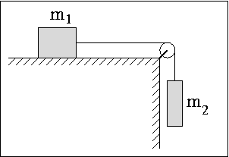 | block one | Forces act on block one:
 | block two | Forces act on block two:

II - Observe
Draw the free body diagram and name the force in each demonstration
Block being pushed |  | Block being pulled | Forces act on the block:
block resting on inclined surface |  |  | Forces act on the block:
Simple pulley system (1) | block one |  | Forces act on the block one:
 | block two |  | Forces act on the block two:
Simple pulley system (2)  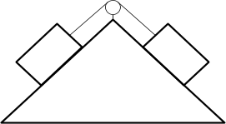 |  |  | Forces act on the block one:
block one (heavier) |  | block two (lighter) | Forces act on the block two:

III - Explain
Characteristics all the common forces acting on a body and state the point of application near the diagram.
Normal forces | Example
Label: | N  e.g. Arrow pointing from the contact surface
Direction of arrows:

Weight | Example
Label:

Direction:

Friction | Example
Label: | Intended moving direction
Direction:

Tension | Example
Label:

Direction:

External force – push /pull | Example
Label: | Push | Pull
Direction:

