Palm-reading
Objectives: | 1. | To revise and give practice in adjectives to describe people.
 | 2. | To give students practice in descriptive writing.
 | 3. | To give students practice in revising and editing their written work by adding more details.
 | 4. | To give students practice in skimming and scanning.
Activities: | 1. | Vocabulary activity - Whole-class work
 | 2. | Skimming and scanning - Individual and pair work
 | 3. | Writing - Individual work
 | 4. | Revising and editing - Individual work
Level: | S1 - S2
Materials: | Article  Worksheet  Revision worksheet

Palm-reading: Steps
1. | Start the lesson by asking the students to tell you different ways of determining a person’s character and predicting their future. Ask the class if they believe that it is possible to look into the future and if any of them have used any of these methods. Tell the class that the topic of the lesson is palm-reading.
 | Vocabulary activity - Whole-class work
2. | Tell the class that palm-reading is an old technique of looking into the future. Explain that the shape of the hand and the lines in the palm supposedly describe the person’s personality and indicate their future.  Draw a large diagram of a hand and the main lines on the board. Label each of the lines.
3. | Ask students to get a blank piece of paper and trace around their hand. Get them to copy the lines of their own hand onto the outline.
4. | When everyone has finished doing this, ask them to write their gender on the front of the sheet of paper and their date of birth on the back.  Collect in all the sheets of paper and tell the class that they will get them back later.
5. | Divide the board into four columns and write one of the following headings at the top of each column:  head, heart, luck, general  Brainstorm adjectives to describe people and write these up under the most appropriate heading(s). Explain any of the target vocabulary that you think your students do not know and add these to the lists on the board.
 | Skimming and scanning - Individual and pair work
6. | Give a copy of the Article to each student. Tell them that the article describes what each line means. Set a time limit for students to read through the article quickly. When they have done this, get them to turn over their pieces of paper and tell their partner as much as they can remember about the article.
7. | Hand out the Worksheet. Tell students to look at the palm and the text on the worksheet. Explain that the text is a fortune teller's interpretation of the meaning of the lines on the palm. The students' task is to fill in the missing words in the text by reading the article again in more detail and looking at the palm.
8. | Monitor as students are doing the activity and provide guidance to those who need it.
9. | Encourage students to compare answers before checking back with the whole class.
 | Writing - Individual work
10. | Shuffle up the papers you collected in step 4. Tell the students that they are each going to look at a diagram of a classmate’s palm to assess their character and predict their future.
11. | Before they start writing, brainstorm with the class what things they can write about. Put these on the board.  Give each student a diagram and ask them to check that they do not have their own!
12. | Ask the class to look carefully at the sheet of paper they have been given and using the information from the Article, write an interpretation of the person’s character and future. Tell them to make notes using the headings on the board.
13. | When they have finished making notes, ask them to write their first draft. Encourage them to use the vocabulary that was introduced earlier.
14. | Go around the class and give help where needed.
 | Revising and editing - Individual work
15. | When everyone has finished, get them to write their name at the top of the page and swap their draft with the person next to them. Give everyone a copy of the Revision worksheet. Go through the instructions on the worksheet and explain that they should concentrate on the content rather than on grammatical accuracy.
16. | As students are doing this exercise, go around the class giving suggestions and commenting on the notes they have made.
17. | When everyone has finished, get them to return the piece of work to the person who wrote it. Instruct everyone to answer the questions and add more details to their descriptions.
18. | Collect in students' work for marking.

Pop-up screen notes
Objectives
Source: | These materials are based on ideas from Francis Leung of Kap Yan Directors' School. We are very grateful to him for his contributions to the network.
Example:
  intelligent
  clever
  intellectual
  emotional
  kind
  generous
  affectionate
  friendly/unfriendly
  lucky/unlucky
  independent
  hard-working/lazy
  serious
  happy
  optimistic
  interesting/boring
  confident/unconfident
  creative
  artistic
Glossary: | Skimming refers to when we read very quickly to get the gist, or main idea, of a text. That is to say, we do not go through and read every word in the text, but skim over the surface. It is sometimes referred to as reading for gist, such as when we skim through a film review to see if the film is worth going to see.  Scanning, on the other hand, is when we read for specific information. Again, we do not read every word, but we know exactly what we are looking for in the text, ie we are trying to find out something specific, such as when we read through the telephone directory to get someone's phone number.
Steps
1. Example:
  astrology
  face-reading
  tarot cards
  palm-reading
1. Note: | It is often a good idea to personalise the subject matter at the beginning of the class for several reasons:
  It gives students an opportunity to voice their opinions and share their experiences.
  It helps to stimulate interest in the topic area.
  It can help bring any knowledge students may have about the topic area to the forefront of their minds.
2. Example: | Lines on the hand
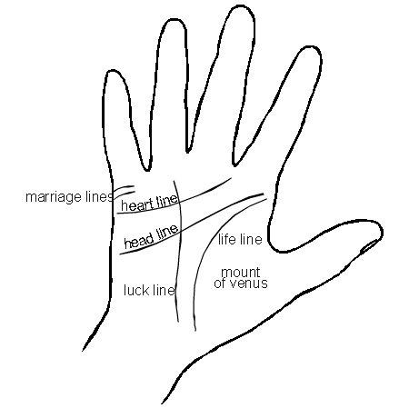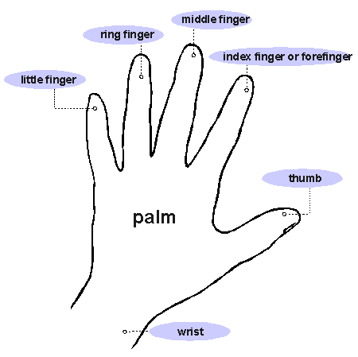
3. Note: | Stress to students that they should copy the lines from their own hands rather than from the board. Explain that each hand is unique and to predict a person's future, it is necessary to have an accurate diagram of the lines on their hand.
4. Explanation: | Students will later swap their diagrams with another student, who will then try to interpret what the lines mean. It is important that they do not know the identity of the student so they are able to write an impartial reading. The date of birth should be written so that the diagram can be returned to the correct person.
5. Example: | Head  Heart  Luck  General
  intelligent
  clever
  intellectual
  emotional
  kind
  generous
  affectionate
  friendly/unfriendly
  lucky/unlucky
  independent
  hard-working/lazy
  serious
  happy
  optimistic
  interesting/boring
  confident/unconfident
  artistic
  creative
Glossary: | See Glossary under "Objectives".
9. Note: | Ask students to tell you what structures are used to describe the person's character (present simple tense) and which tense is used to predict their future (will/may + bare infinitive).
9. Key: | Key - Worksheet (possible answers)
  1. | marriage | 8. | middle/centre
  2. | relationships | 9. | lucky
  3. | longer/deeper | 10. | curve
  4. | clear/thick | 11. | ill/sick/unwell
  5. | intelligent | 12. | independent
  6. | head | 13. | head
  7. | heart
11. Example:
  description of the lines
  the person’s character
  life
  health
  love
  luck

Palm-reading | Article
How can you read someone’s palm? Read the following and find out!
Life line
A deep, smooth life line means you will have good health and lead a long and full life. If there are lots of chains in the line, you may have poor health sometime in your life. If the line changes direction or is very curved, there will be a change in the course of your life.
A triangle in the middle of your life line means you are quite creative and artistic.
Look at the life line and the head line together. If they do not meet, this means you are a very independent person. If there are many lines joining the life line and the head line, this means that some of your ambitions will come true.
Head line
Do you have a long, clear line? If you do, this means you are clever. If your head line joins the heart line, this means you are very intelligent!
Heart line
Compare the lengths of your heart line and head line. Which one is longer? If the heart line is longer, then you are a very emotional person. If the head line is longer, then you are more intellectual.
Luck line
Is your luck line long and deep? If it is, then you will have lots of luck in your life.
Marriage lines
Count the numbers of lines. How many are there? Every line represents a close relationship. Very important relationships are long, deep lines.
Mount of Venus
Look at the mount of Venus. If it is round, then this means you are a kind person and a good friend. If the mount is not round, other people may think you are a little unfriendly. Are there lots of crossed lines? This could mean that you hide a lot of your emotions.
Palm-reading | Worksheet
Here is a fortune teller's interpretation of the lines on the palm shown below. Fill in the missing words by reading the article in more detail and by looking at the palm.
Let's start with your 1.__________________ lines. There are four lines here which suggests that you will have four important or close 2.__________________ in your life. Two of these lines are 3.__________________ than the others so these relationships will probably be more important ones to you. Your head line is very long and very 4.__________________ which means you are an 5.__________________ person. The fact that your 6.__________________ line is longer than your 7.__________________ line means that you are an intellectual person rather than an emotional one. This line running down the 8.__________________ of your hand tells us about your luck in life. Your line is fairly long so you will probably be quite 9.__________________. According to the 10.__________________ in your life line, you will have a major change in your life. The chains in the line also suggest that you may be 11.__________________ at some point in your life. I can tell that you are 12.__________________ because your life line and your 13.__________________ line do not join at the end.

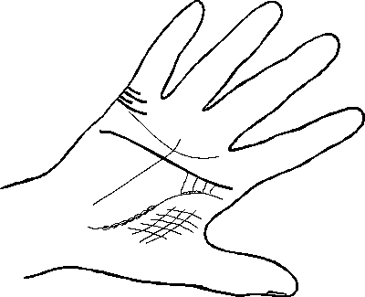

Palm-reading | Revision worksheet
Work on your own. Read the piece of writing you have been given, answer the questions below and indicate where the writer could make some improvements.
Question | Action
Is there any information missing? | At the bottom of the page, write what information is missing.
Is the information organised into clear paragraphs? | Underline any information you think should go into another paragraph.  Draw a line to the appropriate paragraph.
Are the paragraphs easy to understand? | Underline anything you do not understand.  Write I do not understand this in the margin.
Read each paragraph carefully.  Is there anything more you want to know? | Use a different coloured pen. Write questions asking what you want to know.
Read each sentence carefully.  Would you like more details? | Circle where you would like more detailed description and add a note in the margin.
Work on your own. Read the piece of writing you have been given, answer the questions below and indicate where the writer could make some improvements.
Question | Action
Is there any information missing? | At the bottom of the page, write what information is missing.
Is the information organised into clear paragraphs? | Underline any information you think should go into another paragraph.  Draw a line to the appropriate paragraph.
Are the paragraphs easy to understand? | Underline anything you do not understand.  Write I do not understand this in the margin.
Read each paragraph carefully.  Is there anything more you want to know? | Use a different coloured pen. Write questions asking what you want to know.
Read each sentence carefully.  Would you like more details? | Circle where you would like more detailed description and add a note in the margin.

